HACK ANY WIFI
- In this practical, I will show you how to Hack or Crack any WEP/WPA2 PSK security Wi-Fi.
Required Tools & Software's:
- Kali Linux Running as default OS or in Virtual machine.
- One Router of your own to be hacked. You can also use your Mobile Hotspot.
- One Wi-Fi adapter which supports Monitor Mode & packet Injection.
  - How to check for Monitor Mode
iwconfig // to verify device connection and mode
sudo airmon-ng start wlan0 //start device in moinitor mode
iwconfig //verify monitor mode
sudo aireplay-ng --test wlan0mon //test packet injection
iw list | grep AP$ //verify AP mode
- Aircrack-ng Software. (Pre-Installed in Kali Linux)
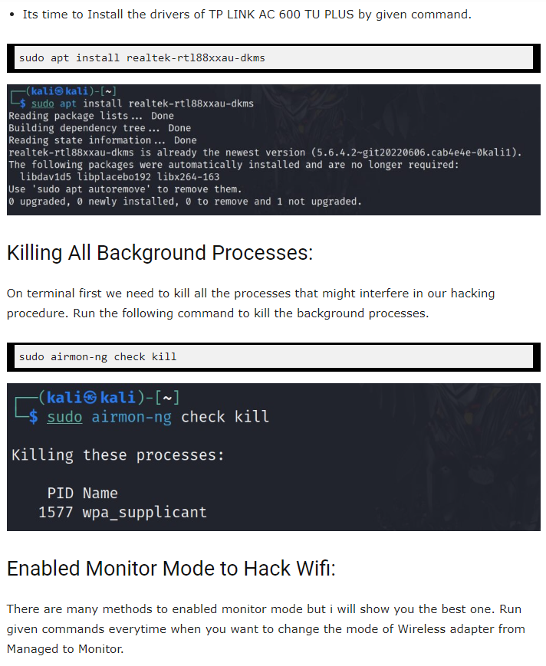
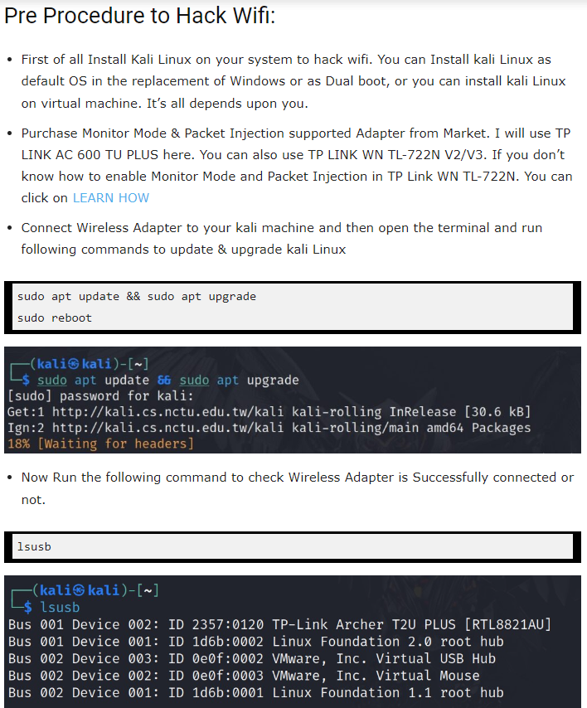


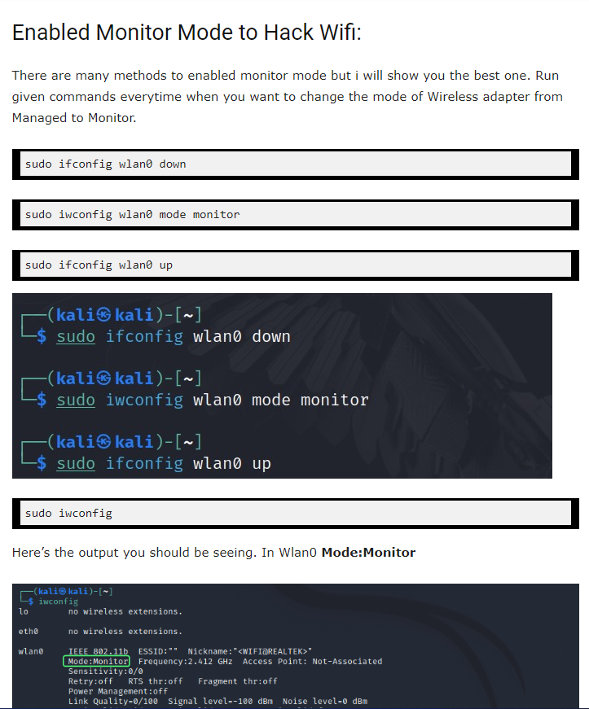

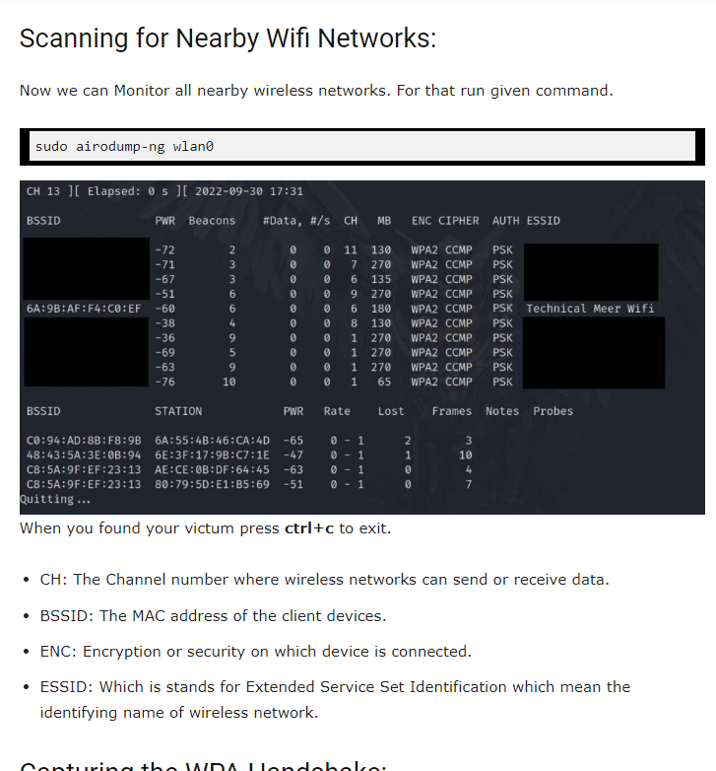

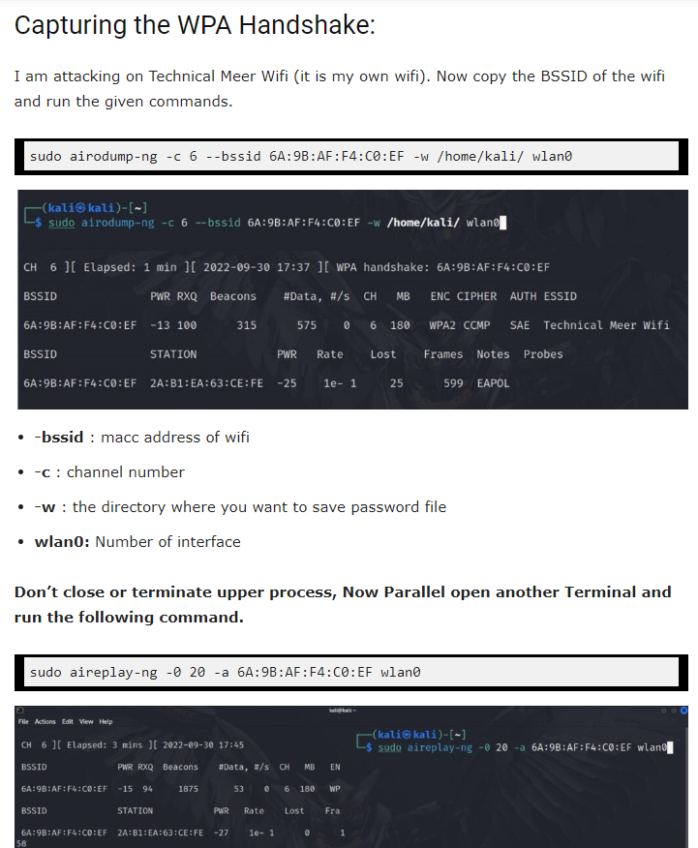
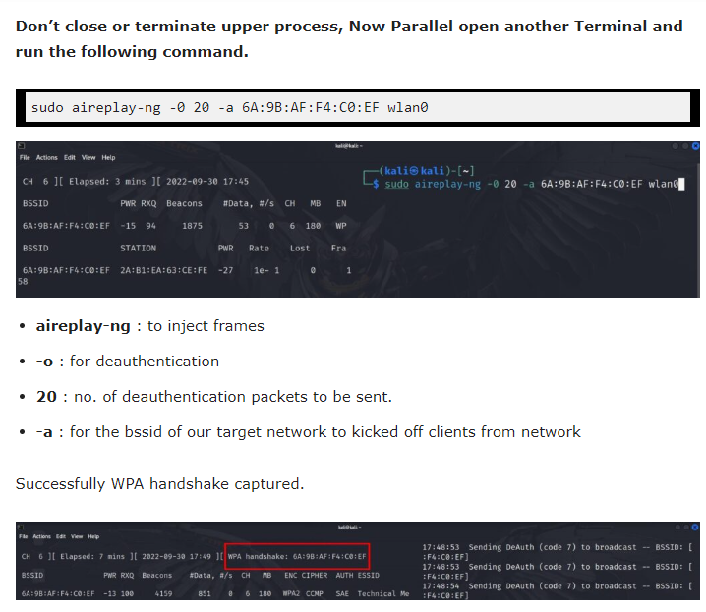

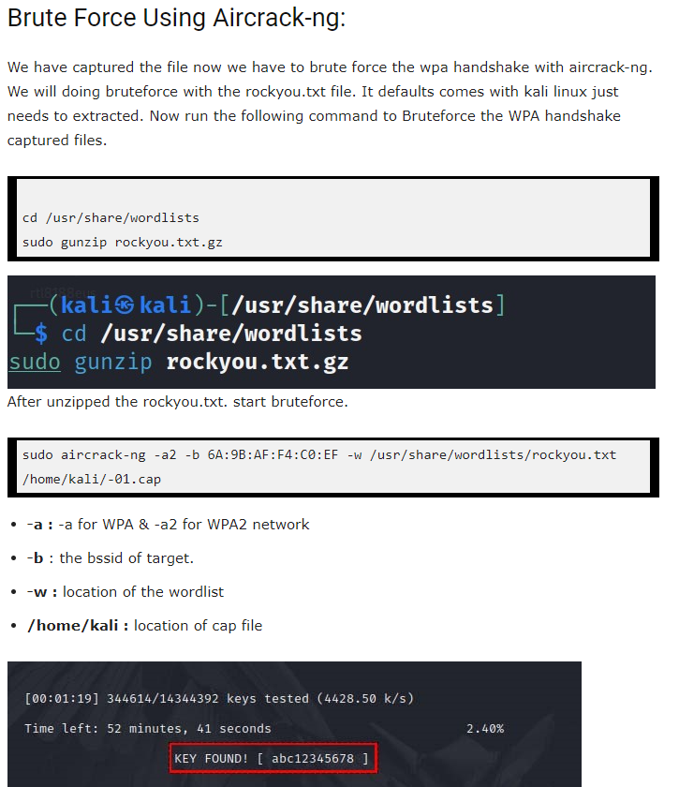


- Nice You hacked the Wi-Fi.
- These types of attacks take too long to crack the password.
- If a user choose strong password it’s too difficult to crack.
- Instead of this attack you can also use evil twin or pixie dust attack which will take less time and give you better result.

